# PROJECT REPORT

## PREPARATION OF MAINTENANCE OF ZOHO BOOKS FOR URBAN AURA

***INTERIORS***

# INTRODUCTION:

## overview:

Urban aura interiors merges industrial with

contemporary design,

creating a modern of look.Its central to

ensure livability of our cities and regional towns.

## Purpose:

It’s a concept of defined by industrial designers makes

products useful and

understandable. Like as honest, make friendly,long lasting.

# PROBLEM DEFINITIONS &THINKING:

## Empathy Map:

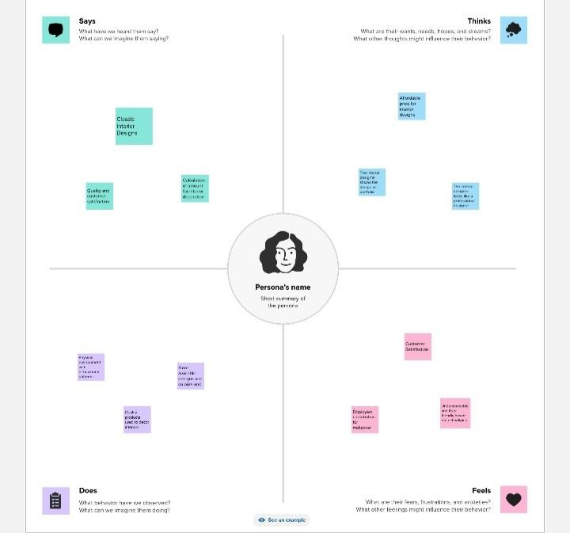

* 1. ***Brand storming:***

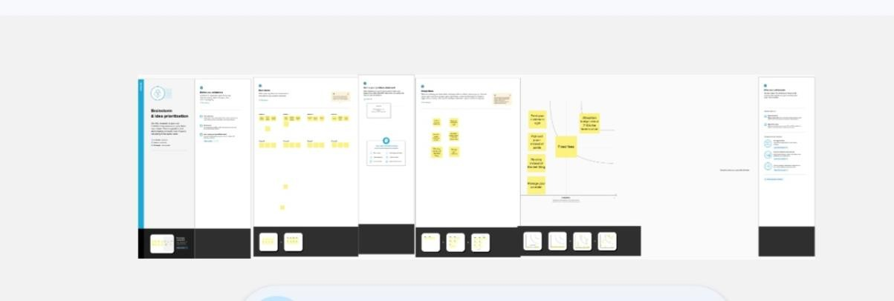

# RESULT:

## Dashboard

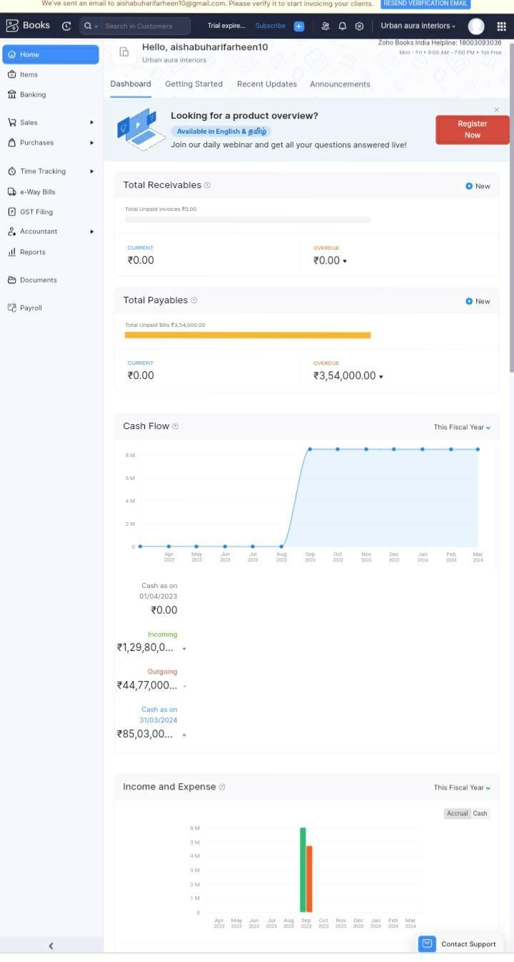

***Profit and loss***

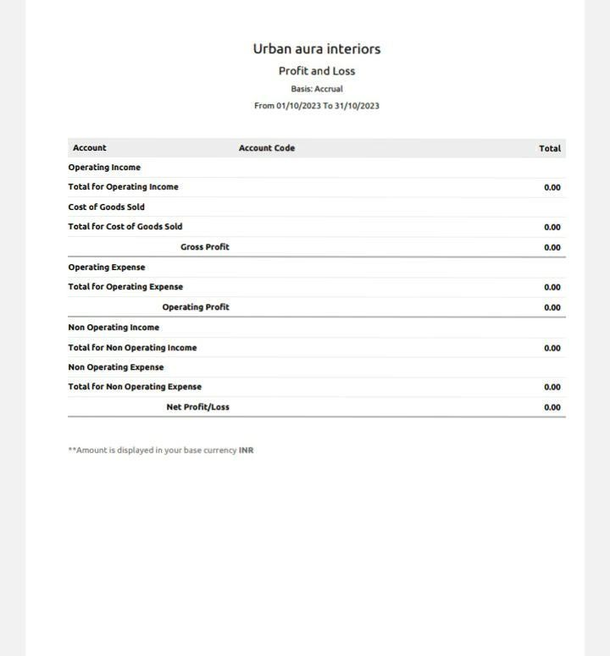

***Balance sheet***

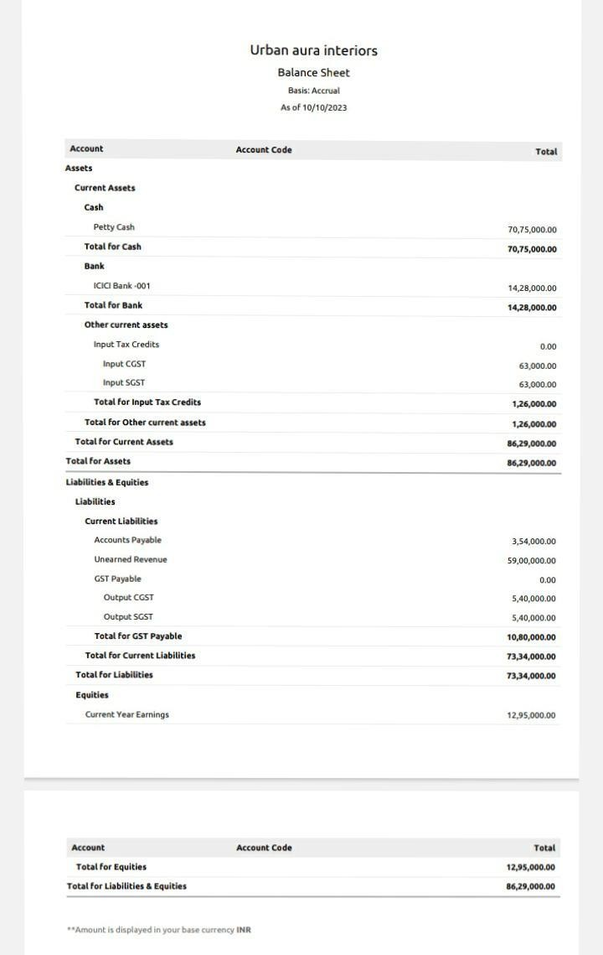

# ADVANTAGES

**&DISADVANTAGES:**

## Advantages:

* Improves the

status and the value of life space.

* It stimulates local economy, attracting tourist to the urban aura.
* It improves quality of life for locals and endless

entertainment options.

* There’s

vibrancy,convenienc e, possibilities of

living in a fastest city.

* Amenities to design and shape physical features of town and regional spaces.

## Disadvantages:

* Limited availability and it’s take time of long working hours.
* Low income in the beginning.
* Keeping clients wishes and

constraints top of mind.

* Biggest struggle of managing

cost,labour, material, marketing to when

you’re run a

business.

* Stressfull of work and budget is the biggest challenge of interior design.

# conclusion:

Its the plan of urban development of importance to

everyone’s life.Its

make a generating of economic growth of our country and may be balanced with social and economic welfare.

To enhance the qualities, trends,

relationships,

systematic and critical

analysis of literature on this specific topic. To centralised design elements are to be focused.

It exists an idea first and it is to be brought to reality through

careful

planning.At it’s best an interior designing concept is a

visual theme as that evokes specific mood

strategically using color,space,and styles.